**D.A.V. MODEL SCHOOL**

**SECTOR 15 A CHANDIGARH**

**CLASS-XII**

**CBSE RESULT 2021-2022**

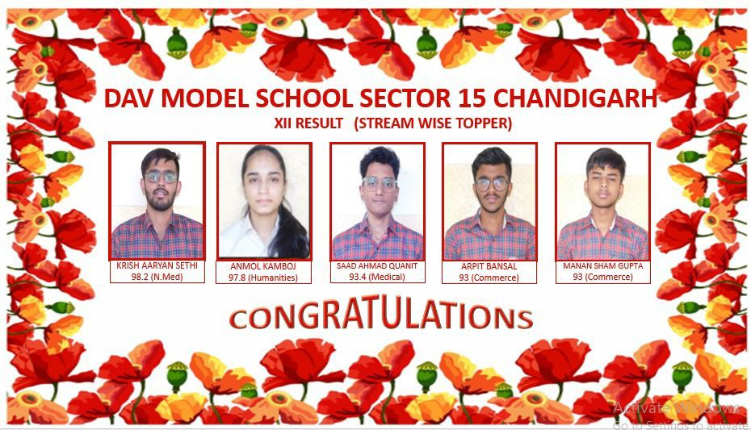

**Stream wise topper**

**Arts**

1. **Anmol Kamboj- 97.8 %**
2. **Akshita Sharma- 95.6%**
3. **Aadrika- 94.2%**

**Medical**

1. **Saad Ahmad - 93.4 %**
2. **Aditya Sharma- 90.8%**
3. **Gurshaan Singh- 90.4%**

**Non-Medical**

1. **Krish Aaryan Sethi- 98.2 %**
2. **Dilbar Singh Lamba- 97.2%**
3. **Vansh Abbott- 96.2%**

**Commerce**

1. **Arpit Bansal & Manan Sham Gupta- 93 %**
2. **Ricky Mittal- 92.6%**
3. **Manish Kumar- 91.8%**

**DAV Model School Sector-15A, Chandigarh**

**CBSE RESULTS XII-SESSION 2021-2022**

School QPI -80.45

**1ST Position Krish Aaryan Seth (Non Medical) : 98.2 %**

2nd Position (Anmol Kamboj – Arts) **:** 97.8%

3rd Position (Dilbar Singh Lamb – Non-Med) **:** 97.2%

4TH Position (Vansh Abbott – Non-Med) **:** 96.2%

No. of students above 90% **:** 25

No. of students above 80% **:** 80

No. of students above 75% **:** 100

No. of students above 70% **:** 120

First division 60% & above **:** 142

Overall School QPI **:** 80.45

Total Students Registered **:** 143

No. of students appeared **:** 143