Chandan Kumar

## I.A.S.

Collector

& District Magistrate

# Distt.- Sukma (C.G.)



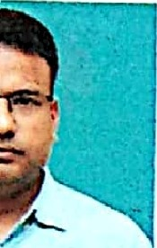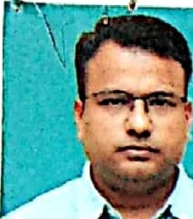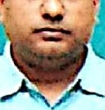

## Ph. Office -07864-284001

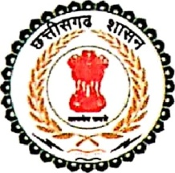Fax -07864-284002

Resi -07864-284005

E -M âÎ l-dmsukma [.cg@gmail.com](mailto:.cg@gmail.com) [sukma.cg@nic.in](mailto:sukma.cg@nic.in)

OFFICE OF THE COLLECTOR, DISTT. SUKMA(C.G.)

D.0.No./ J9) DM/20 CO Sukma Datent log /20ZO

***CHAIRMAN’S MESSA GE***

DAV Mukhyamantri Public Schools have been functioning in Sukma since 2016. The education should be one that shall ameliorate the living standards of these tribal students. The students should turn out to be strong emotionally, socially and academics as well. This will bring great courage and confidence to face real life situations in the society. DAV is one old and prestigious and non-profit organization that believes working for welfare of all.

In 20l3,The Associated Chambers of Commerce and Industry of India (ASSOCHAM) awarded DAV College Managing Committee with 'Best Chain of Schools in Tndia' award for its exemplary contribution to quality education. The organization' emphasizes on imparting good sound education, nobility of character, refinement of manners and amiability of temper as envisaged by Swamy Dayanand Sarassvatiji.

DAV Mukhyamantri Public Schools at Sukma have been putting all its endeavours to bring up good educational standards among the children. Importance is given to value based education.

The selection committee takes the onus of selecting qualitative and committed staff whose performance skills are further enhanced by conducting periodical workshops and by the continuous supervision of the principal.

l wish the school to do a great job in imparting best education to benefit the tribal students of thèse areas and contribute to their progress and success.

Wishing You All The Best,



**(Chandan Kumar)**



Scanned with CamScanner