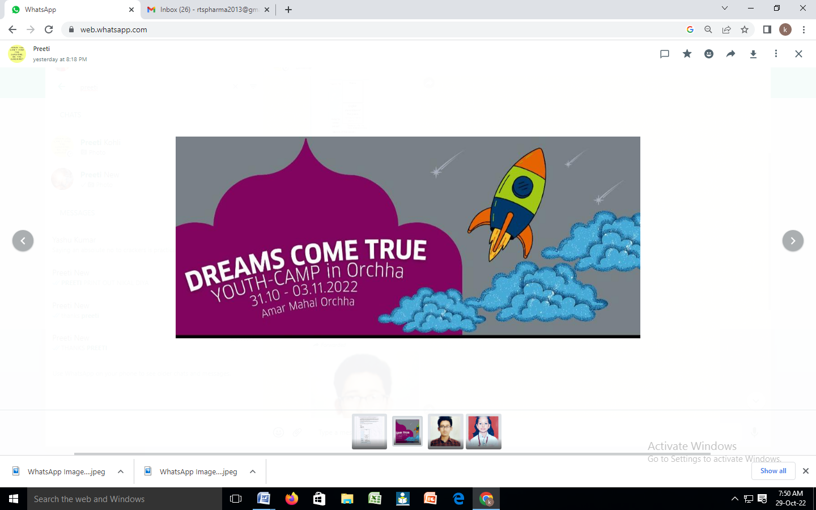

Congratulations!!

Träume werden wahr (Dreams come true) - Youth Camp in Orchha

(Amar Mahal Orchha)

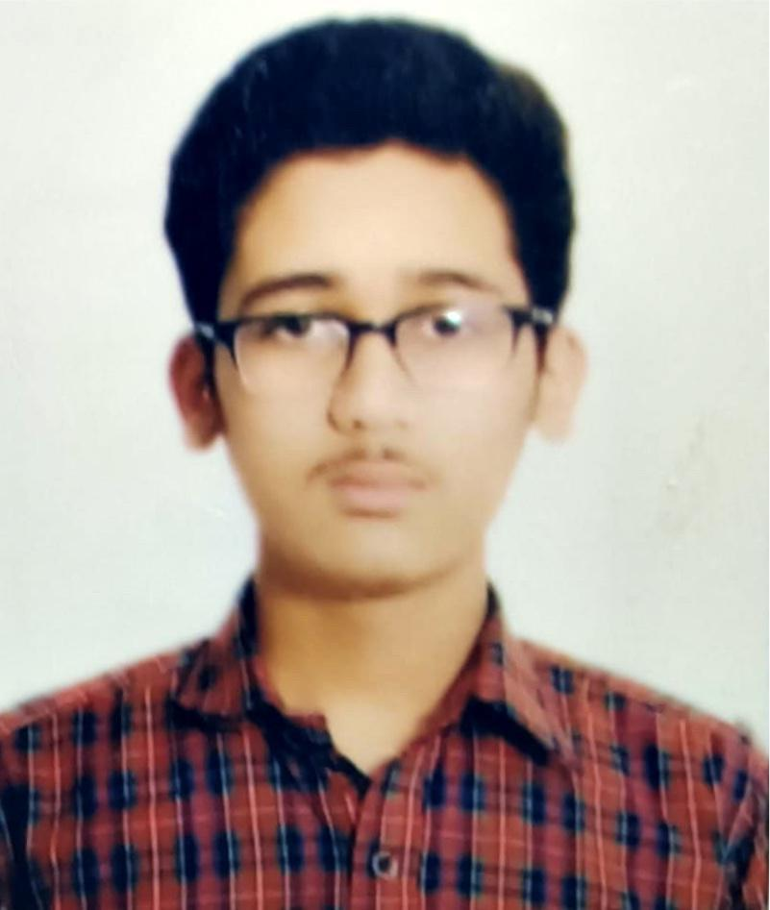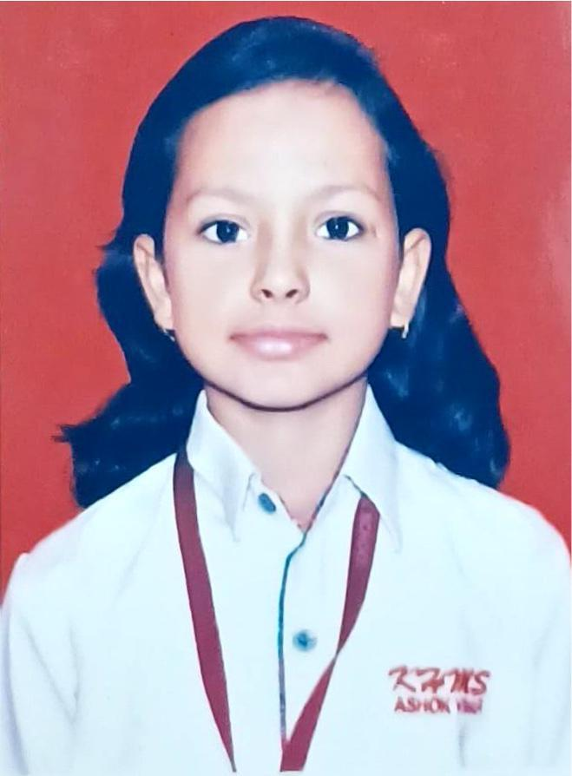A Youth Camp in Orchha for German learners, who have excelled in the FIT-1 exam this year, is organised by Goethe Institute. Therefore two students i.e Prachi Agarwal of Class VIII F and Akshat Kandpal of Class VIII K , from KHMS are selected for the Youth Camp and the opportunity to stay at Amar Mahal Orchha.